Objective:

Take a CSS layout examples from the Web and break it apart to try and understand how it works. Modify its colours, size, etc. and try and customise it to suit your needs.

You must submit a PDF that contains screenshots of your modified layout along with the original layout and your description/explanation of how it works. The more you can understand of your chosen layout, the easier you will find working with CSS.

Original Page:

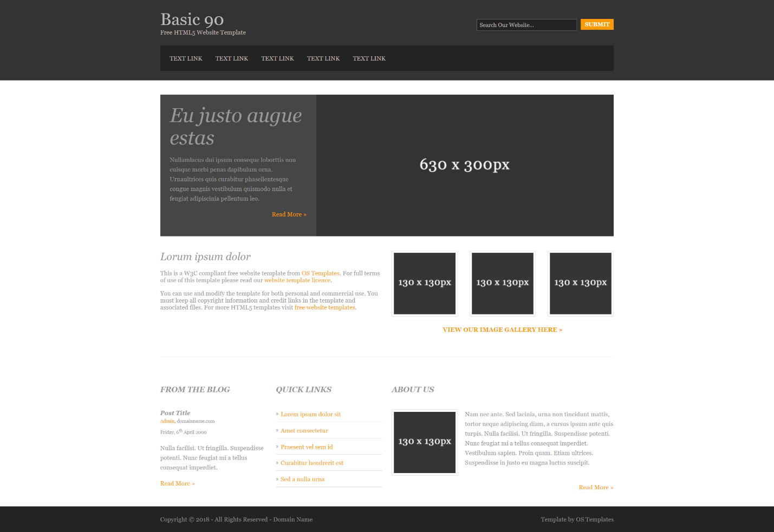

Analysis:

**The original template separates itself into segments by comments, making dissection very easy:**

* **Template**
* **HTML 5 Overrides**
* **Wrapper**
* **Generalize**
* **Header**
* **Content Area**
  + **Slider**
  + **Main Content**
  + **Blogposts**
  + **Quick Links**
* **Footer**

**Here we see that even before the actual content we get four (4) entire segments that are just general prep for the content (Template, HTML5 Overrides, Wrapper, Generalize) while three (3) segments are for specific content areas (Header, Content Area, Footer). Additionally, when the coder wants to use a non-standard solution they add a comment directly on it (Ex. “/* Forces a scrollbar when the viewport is larger than the websites content - CSS3 */”)**

**The template sets the entire color for the page as well as the standard font early on with a set of rules for the body:** body{margin:0; padding:0; font-size:13px; font-family:Georgia, "Times New Roman", Times, serif; color:#919191; background-color:#232323;}

Then it sets rules for all a type links, code and images:

a{outline:none; text-decoration:none;}

code{font-weight:normal; font-style:normal; font-family:Georgia, "Times New Roman", Times, serif;}

.fl_left{float:left;}

.fl_right{float:right;}

img{margin:0; padding:0; border:none; line-height:normal; vertical-align:middle;}

.imgholder, .imgl, .imgr{padding:4px; border:1px solid #D6D6D6; text-align:center;}

.imgl{float:left; margin:0 15px 15px 0; clear:left;}

.imgr{float:right; margin:0 0 15px 15px; clear:right;}

**After that we go into overrides where it sets a series of rules for all of the sections of the site: (address, article, aside, figcaption, figure, footer, header, nav, section) to force it to conform:**  
address, article, aside, figcaption, figure, footer, header, nav, section{display:block; margin:0; padding:0;}

q{display:block; padding:0 10px 8px 10px; color:#979797; background-color:#ECECEC; font-style:italic; line-height:normal;}

q:before{content:'“ '; font-size:26px;}

q:after{content:' „'; font-size:26px; line-height:0;}

**After this it sets up a wrapper to unify the style of any content included in the wrapper:**

div.wrapper{display:block; width:100%; margin:0; padding:0; text-align:left;}

.row1, .row1 a{color:#C0BAB6; background-color:#333333;}

.row2{color:#979797; background-color:#FFFFFF;}

.row2 a{color:#FF9900; background-color:#FFFFFF;}

.row3, .row3 a{color:#919191; background-color:#232323;}

**Then it sets general rules for how content should look in terms of text, forms, and fields:**

#header, #container, #footer{display:block; width:960px; margin:0 auto;}

nav ul{margin:0; padding:0; list-style:none;}

h1, h2, h3, h4, h5, h6{margin:0; padding:0; font-size:22px; font-weight:normal; font-style:italic; line-height:normal;}

address{font-style:normal;}

blockquote, q{display:block; padding:8px 10px; color:#979797; background-color:#ECECEC; font-style:italic; line-height:normal;}

blockquote:before, q:before{content:'“ '; font-size:26px;}

blockquote:after, q:after{content:' „'; font-size:26px; line-height:0;}

form, fieldset, legend{margin:0; padding:0; border:none;}

legend{display:none;}

input, textarea, select{font-size:12px; font-family:Georgia,"Times New Roman",Times,serif;}

.one_quarter, .two_quarter, .three_quarter, .four_quarter{display:block; float:left; margin:0 20px 0 0;}

.one_quarter{width:225px;}

.two_quarter{width:470px;}

.three_quarter{width:715px;}

.four_quarter{width:960px; float:none; margin-right:0; clear:both;}

.one_third, .two_third, .three_third{display:block; float:left; margin:0 30px 0 0;}

.one_third{width:300px;}

.two_third{width:630px;}

.three_third{width:960px; float:none; margin-right:0; clear:both;}

.lastbox{margin-right:0;}

**Then it goes into specific styling of elements in the Header, Content and Footer segments with sub-sections for Content area that shape the slider, main, blog entries and quick links to parts of the site.**

**Header:**

#header{padding:20px 0;}

#header #hgroup{float:left; margin:0 0 20px 0;}

#header #hgroup h1, #header #hgroup h2{font-weight:normal; font-style:normal; text-transform:none;}

#header #hgroup h1{font-size:36px;}

#header #hgroup h2{font-size:13px;}

#header form{display:block; width:290px; float:right; margin:20px 0; padding:0;}

#header form input{display:block; float:left; width:200px; margin:0; padding:5px; color:#C0BAB6; background-color:#232323; border:1px solid #666666;}

#header form #sf_submit{display:block; float:right; width:70px; font-size:12px; font-weight:bold; text-transform:uppercase; color:#FFFFFF; background-color:#FF9900; border:none; cursor:pointer;}

#header nav{display:block; width:100%; margin:0; padding:20px 0; color:#C0BAB6; background-color:#232323; clear:both;}

#header nav ul{padding:0 20px;}

#header nav li{display:inline; margin-right:25px; text-transform:uppercase;}

#header nav li.last{margin-right:0;}

#header nav li a{color:#C0BAB6; background-color:#232323;}

#header nav li a:hover{color:#FF9900; background-color:#232323;}

**Content Area:**

#container{padding:30px 0;}

#container section{display:block; margin-bottom:30px; padding:0;}

#container .last{margin:0;}

#container .more{text-align:right;}

/* ------Slider-----*/

#container #slider{width:100%;}

#container #slider figure{}

#container #slider figure img{float:right; width:630px; height:300px;}

#container #slider figure figcaption{display:block; float:left; width:290px; height:260px; padding:20px; overflow:hidden; color:#989898; background-color:#464646; line-height:1.6em;}

#container #slider figure figcaption a{color:#FF9900; background-color:#464646;}

#container #slider figure h2{font-size:42px; font-weight:normal; font-style:italic; text-transform:none;}

#container #slider figure footer{}

/* ------Main Content-----*/

#container #intro{width:100%; margin-bottom:60px; padding-bottom:20px; border-bottom:1px solid #D6D6D6;}

#container #intro section{width:100%;}

#container #intro section article{}

#container #intro section article h2{margin-bottom:15px;}

#container #intro section article p{}

#container #intro section article figure ul{display:block; width:100%; margin:0; padding:0; list-style:none;}

#container #intro section article figure ul li{display:inline-block; float:left; margin:0 25px 0 0;}

#container #intro section article figure ul li.last{margin:0;}

#container #intro section article figure ul li img{width:130px; height:130px; margin:0; padding:4px; border:1px solid #D6D6D6;}

#container #intro section article figure figcaption{display:block; width:100%; margin-top:20px; clear:both; text-align:center; text-transform:uppercase; font-weight:bold;}

#container #homepage{display:block; width:100%; line-height:1.6em;}

#container #homepage section{margin-bottom:0;}

#container #homepage section h2.title{margin:0 0 25px 0; padding:0 0 8px 0; font-size:16px; font-weight:bold; text-transform:uppercase;}

#container #homepage section footer{clear:both;}

/* ------Blogposts-----*/

#container #homepage section article header h2{font-size:13px; font-weight:bold;}

#container #homepage section article address, #container #homepage section article time{font-size:10px; font-style:normal;}

#container #homepage section article footer{text-align:left;}

/* ------Quick Links-----*/

#container #homepage section nav li{margin:0 0 8px 0; padding:0 0 5px 0; border-bottom:1px solid #D6D6D6;}

#container #homepage section nav li.last{margin:0;}

#container #homepage section nav a{padding:0 0 0 10px; background:url("../images/arrow.gif") left center no-repeat;}

**Footer:**

#footer{padding:20px 0;}

#footer p{margin:0; padding:0;}

Edits:

From this, we can make edits to the code to do things such as:

**Change the fonts of the page**

Original: body{margin:0; padding:0; font-size:13px; font-family:Georgia, "Times New Roman", Times, serif; color:#919191; background-color:#232323;}

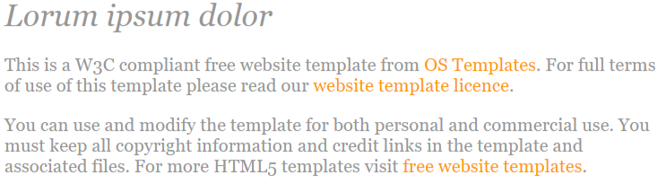

Altered: body{margin:0; padding:0; font-size:13px; font-family: Impact, Charcoal, sans-serif; color:# 919191; background-color:#232323;}



**Change the colors of the page**

Original: .row1, .row1 a{color:#C0BAB6; background-color:#333333;}

.row2{color:#979797; background-color:#FFFFFF;}

.row2 a{color:#FF9900; background-color:#FFFFFF;}

.row3, .row3 a{color:#919191; background-color:#232323;}



Altered: .row1, .row1 a{color:#C0BAB6; background-color:#850002;} CHANGES THE HEADER TO DARK RED

.row2{color:#979797; background-color:#000000;} CHANGES THE BODY TO BLACK

.row2 a{color:#FF9900; background-color:#FFFFFF;}

.row3, .row3 a{color:#919191; background-color:#850002;} CHANGES THE FOOTER TO DARK RED

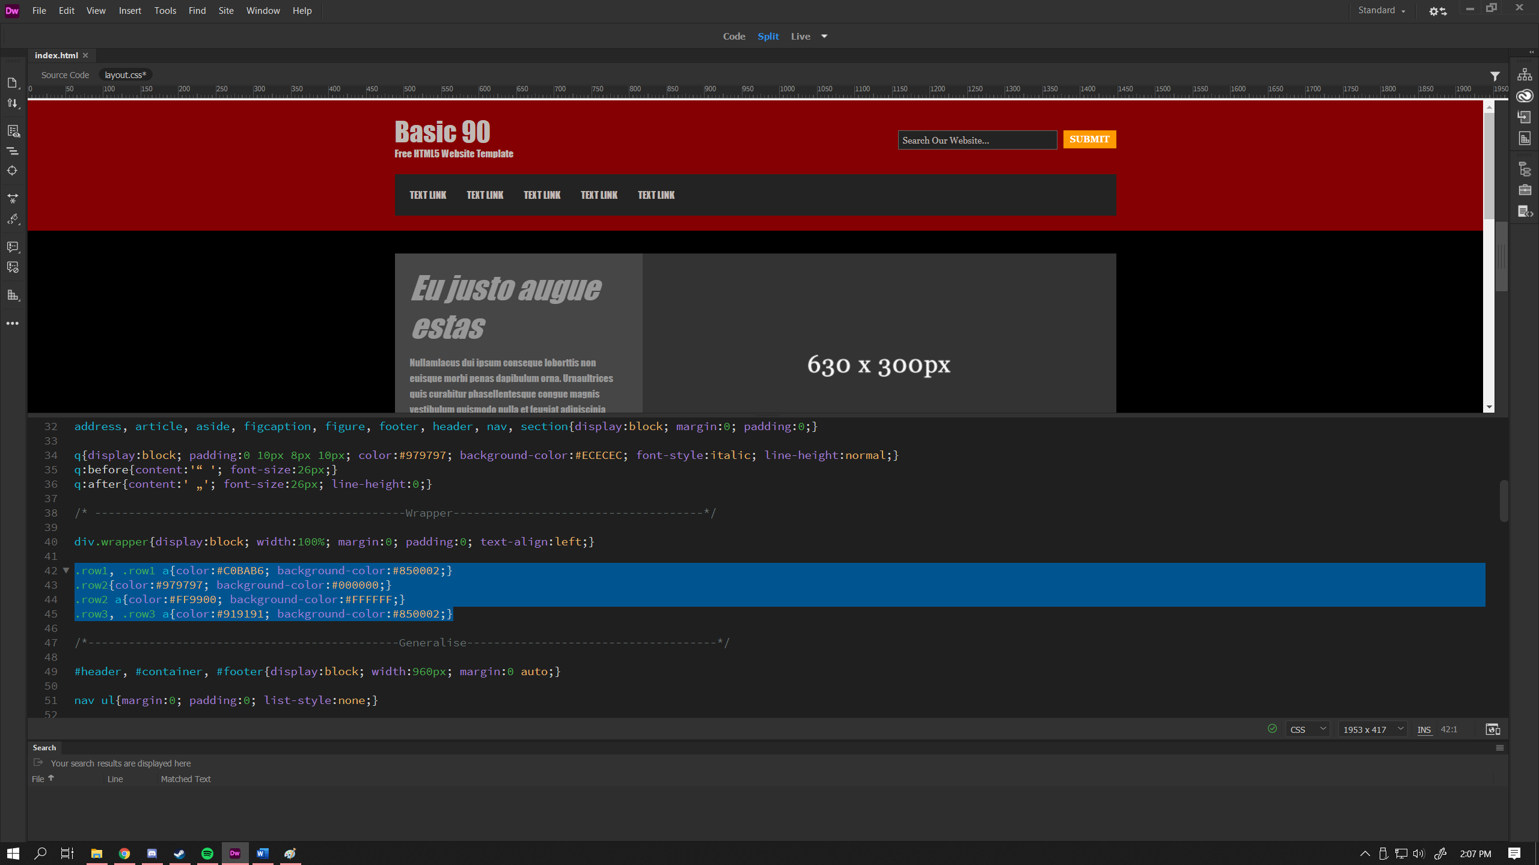

Final Page:

